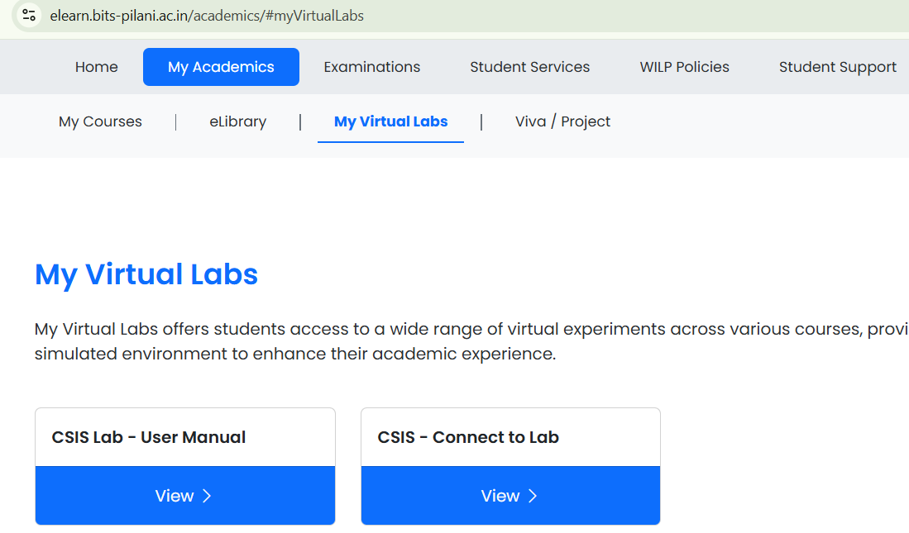

Connect to Lab
First time opening Select subject Book button
Wait few minutes.
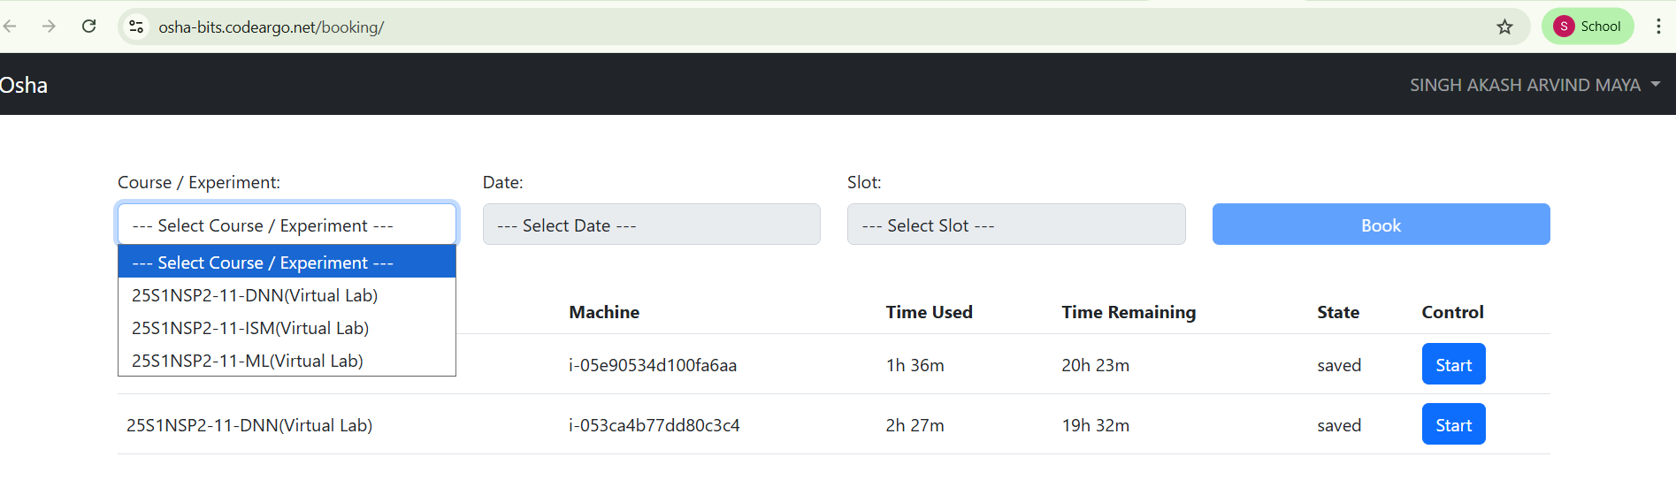
Click on start.
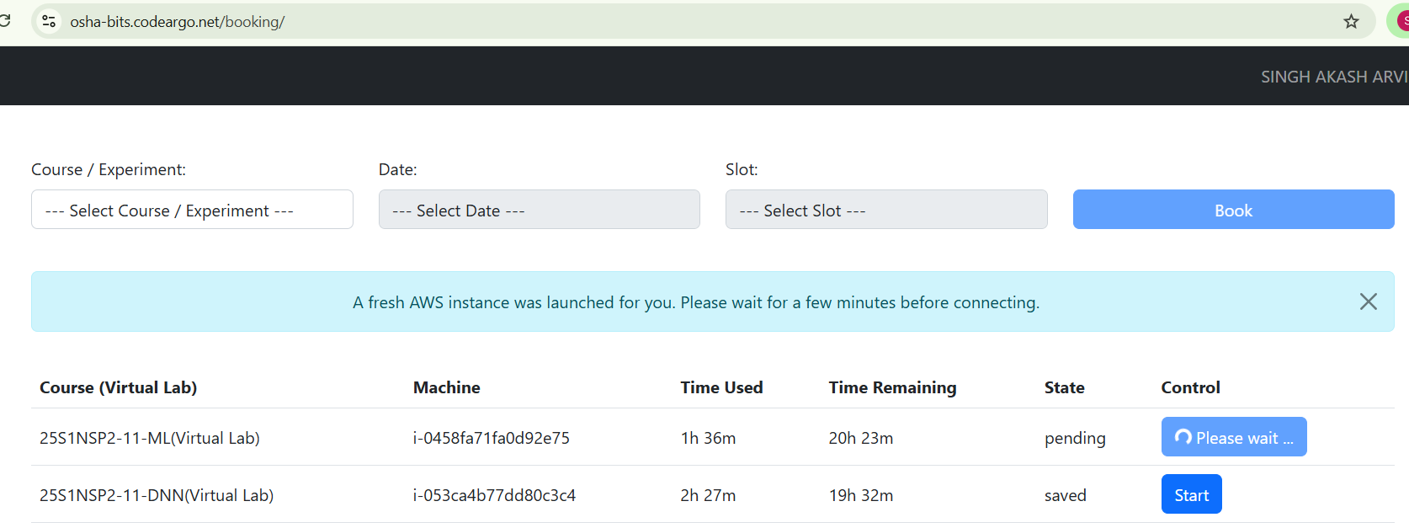
Wait few minutes.
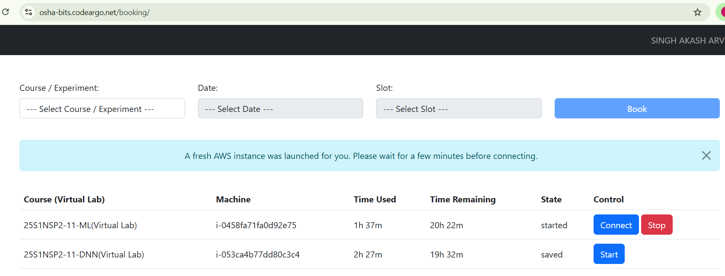
Click on Connect
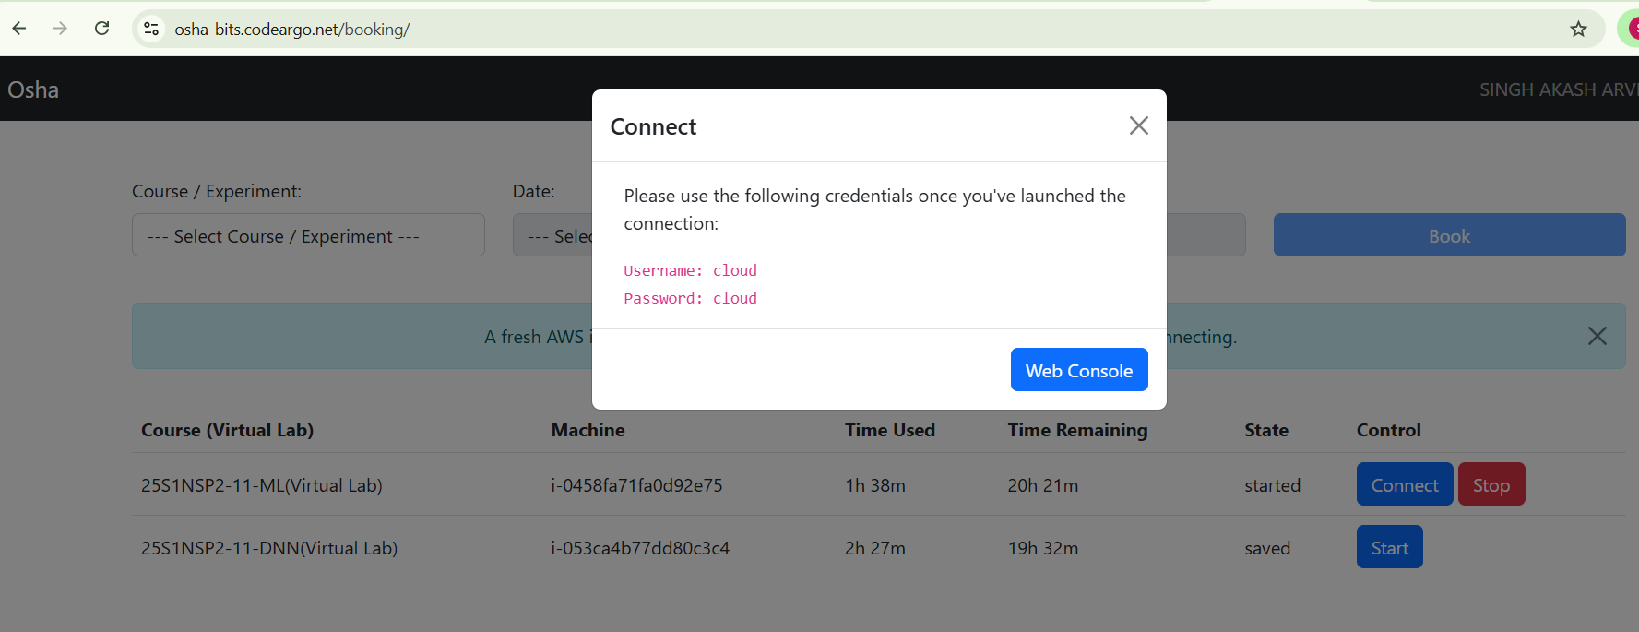
Click on Web Console
Wait few minutes.
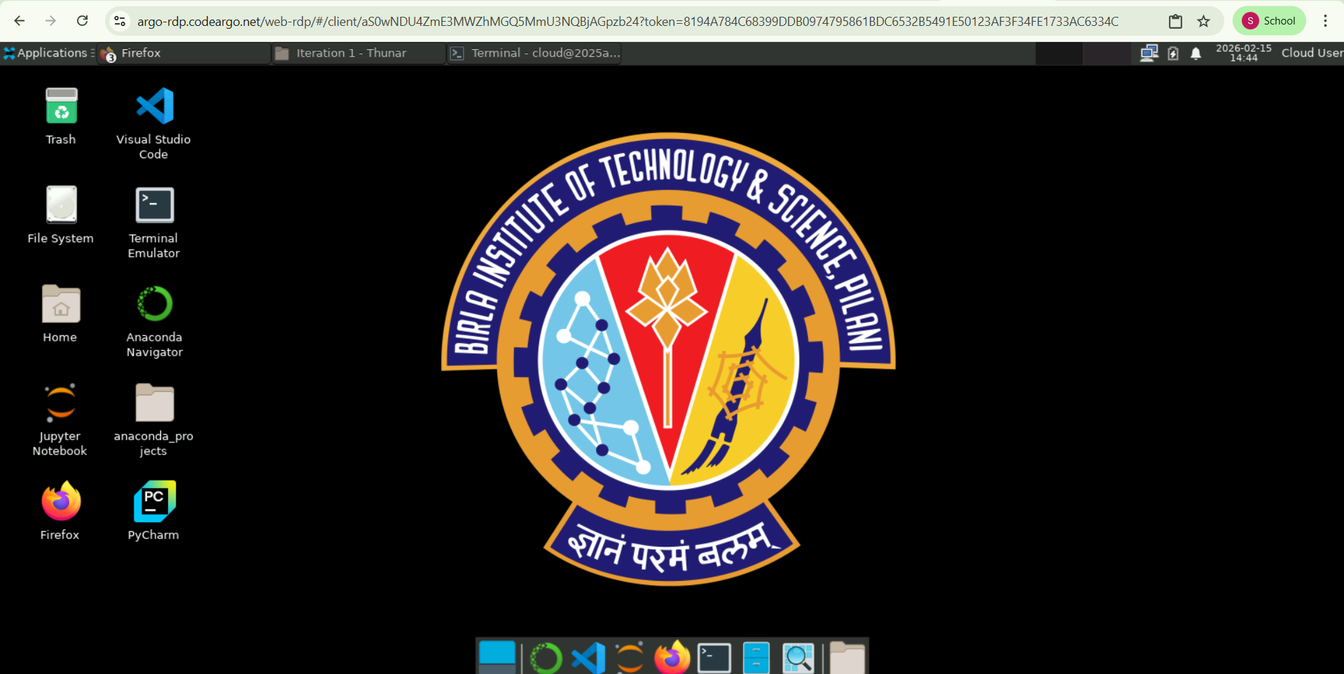

Open Firefox.
Sign in to Google. Upload and download files from Google drive as per requirement.

